# 图像特征选择与距离选择专题测试报告

数据集：总共2218张

横幅137

火灾104

水灾183

天安门188

政府文件167

政治人物（共1439）

奥巴马 118

李克强 154

刘云山 120

普京 126

王岐山 181

希拉里 120

习近平 160

俞正声 182

张德江 159

张高丽 119

测试特征：

CEDD

FCTH

EdgeHistogram

Gabor

JCD

PHOG

Tamura

测试距离：

欧氏距离 $dist\left(X,Y\right)=\sqrt{\sum_{1}^{n}{{(x-y)}^{2}}}$

余弦距离 $sim\left(X,Y\right)=cosθ= \frac{x*y}{\left|x\right|*|y|}$

Tanimoto距离（广义Jaccard距离）

$$d=1-\frac{a_{1}b_{1}+a_{2}b_{2}+….{+a}_{n}b_{n}}{\sqrt{\left(a_{1}^{2}+a_{2}^{2}+…+a_{n}^{2}\right)} +\sqrt{\left(b_{1}^{2}+b_{2}^{2}+…+b_{n}^{2}\right) } -(a_{1}b_{1}+a_{2}b_{2}+….{+a}_{n}b_{n})}$$

测试整体情况：

（1）特征

分为包括人物和不包括人物两项测试

在不包括人物上，CEDD，FCTH，JCD拥有较好效果。

在“不单纯”图像上，CEDD， FCTH， JCD表现较好

在类别“火灾”下，FCTH的表现大致比CEDD好一倍，其他相差不大，各有千秋

类别“天安门”，CEDD，FCTH，JCD均不是最好，最好为PHOG和Tamura

“政治人物”大类FCTH表现较好

具体政治人物所有特征均没有效果

（2）距离公式：

经过多组的实验表明，欧式距离的效果最差，但是花费的时间最少。余弦距离的效果优于欧式距离而差于Tanimoto距离，花费的时间比欧式距离略多。Tanimoto距离是效果最好的，但是计算Tanimoto距离消耗的时间最多。经过权衡，最终选择Tanimoto距离来衡量点之间的距离

## 特征测试：

### 准确率（人物）：

CEDD

|  |  |  |  |  |  |  |  |  |  |
| --- | --- | --- | --- | --- | --- | --- | --- | --- | --- |
| 奥巴马 | 李克强 | 刘云山 | 普京 | 王岐山 | 希拉里 | 习近平 | 俞正声 | 张德江 | 张高丽 |
| '9/10 | '10/10 | '10/10 | '10/10 | '7/10 | '10/10 | '10/10 | '10/10 | '10/10 | '10/10 |
| '19/20 | '19/20 | '19/20 | '19/20 | '9/20 | '18/20 | '20/20 | '16/20 | '20/20 | '20/20 |
| '29/30 | '25/30 | '27/30 | '29/30 | '14/30 | '25/30 | '28/30 | '23/30 | '30/30 | '30/30 |
| '38/40 | '35/40 | '35/40 | '38/40 | '20/40 | '29/40 | '38/40 | '30/40 | '40/40 | '40/40 |
| '47/50 | '45/50 | '41/50 | '48/50 | '28/50 | '37/50 | '47/50 | '36/50 | '49/50 | '50/50 |
| '55/60 | '54/60 | '49/60 | '58/60 | '35/60 | '45/60 | '57/60 | '44/60 | '59/60 | '60/60 |
| '65/70 | '62/70 | '59/70 | '68/70 | '40/70 | '51/70 | '67/70 | '51/70 | '69/70 | '70/70 |
| '75/80 | '71/80 | '68/80 | '77/80 | '47/80 | '57/80 | '75/80 | '57/80 | '78/80 | '80/80 |
| '85/90 | '79/90 | '78/90 | '84/90 | '52/90 | '62/90 | '82/90 | '61/90 | '86/90 | '89/90 |
| '93/100 | '88/100 | '88/100 | '94/100 | '57/100 | '72/100 | '92/100 | '69/100 | '95/100 | '99/100 |

FCTH

|  |  |  |  |  |  |  |  |  |  |
| --- | --- | --- | --- | --- | --- | --- | --- | --- | --- |
| 奥巴马 | 李克强 | 刘云山 | 普京 | 王岐山 | 希拉里 | 习近平 | 俞正声 | 张德江 | 张高丽 |
| '9/10 | '8/10 | '8/10 | '10/10 | '3/10 | '10/10 | '9/10 | '10/10 | '8/10 | '10/10 |
| '18/20 | '18/20 | '15/20 | '20/20 | '9/20 | '20/20 | '18/20 | '18/20 | '18/20 | '20/20 |
| '27/30 | '25/30 | '17/30 | '30/30 | '15/30 | '29/30 | '27/30 | '28/30 | '25/30 | '29/30 |
| '36/40 | '31/40 | '22/40 | '40/40 | '23/40 | '39/40 | '35/40 | '38/40 | '33/40 | '39/40 |
| '44/50 | '37/50 | '28/50 | '50/50 | '32/50 | '48/50 | '44/50 | '47/50 | '41/50 | '49/50 |
| '53/60 | '42/60 | '33/60 | '60/60 | '38/60 | '57/60 | '54/60 | '55/60 | '50/60 | '59/60 |
| '61/70 | '49/70 | '37/70 | '69/70 | '46/70 | '67/70 | '64/70 | '63/70 | '57/70 | '69/70 |
| '68/80 | '57/80 | '44/80 | '79/80 | '52/80 | '75/80 | '74/80 | '68/80 | '64/80 | '79/80 |
| '76/90 | '65/90 | '51/90 | '88/90 | '59/90 | '84/90 | '83/90 | '77/90 | '71/90 | '87/90 |
| '84/100 | '73/100 | '57/100 | '98/100 | '67/100 | '93/100 | '93/100 | '84/100 | '77/100 | '97/100 |

EdgeHistogram

|  |  |  |  |  |  |  |  |  |  |
| --- | --- | --- | --- | --- | --- | --- | --- | --- | --- |
| 奥巴马 | 李克强 | 刘云山 | 普京 | 王岐山 | 希拉里 | 习近平 | 俞正声 | 张德江 | 张高丽 |
| '9/10 | '9/10 | '10/10 | '9/10 | '4/10 | '9/10 | '10/10 | '8/10 | '10/10 | '10/10 |
| '18/20 | '19/20 | '19/20 | '19/20 | '11/20 | '19/20 | '20/20 | '13/20 | '19/20 | '19/20 |
| '27/30 | '28/30 | '29/30 | '29/30 | '16/30 | '26/30 | '30/30 | '22/30 | '27/30 | '28/30 |
| '37/40 | '36/40 | '37/40 | '38/40 | '21/40 | '33/40 | '39/40 | '32/40 | '37/40 | '38/40 |
| '46/50 | '46/50 | '47/50 | '48/50 | '23/50 | '41/50 | '49/50 | '37/50 | '46/50 | '46/50 |
| '54/60 | '56/60 | '55/60 | '57/60 | '31/60 | '49/60 | '57/60 | '45/60 | '55/60 | '55/60 |
| '62/70 | '63/70 | '62/70 | '67/70 | '38/70 | '57/70 | '67/70 | '51/70 | '64/70 | '65/70 |
| '68/80 | '71/80 | '71/80 | '76/80 | '44/80 | '64/80 | '74/80 | '58/80 | '71/80 | '74/80 |
| '76/90 | '80/90 | '78/90 | '86/90 | '51/90 | '70/90 | '82/90 | '65/90 | '79/90 | '84/90 |
| '84/100 | '90/100 | '86/100 | '95/100 | '58/100 | '80/100 | '90/100 | '72/100 | '88/100 | '94/100 |

Gabor

|  |  |  |  |  |  |  |  |  |  |
| --- | --- | --- | --- | --- | --- | --- | --- | --- | --- |
| 奥巴马 | 李克强 | 刘云山 | 普京 | 王岐山 | 希拉里 | 习近平 | 俞正声 | 张德江 | 张高丽 |
| '8/10 | '8/10 | '10/10 | '7/10 | '9/10 | '7/10 | '9/10 | '9/10 | '9/10 | '8/10 |
| '16/20 | '15/20 | '16/20 | '15/20 | '13/20 | '14/20 | '17/20 | '16/20 | '18/20 | '17/20 |
| '23/30 | '24/30 | '24/30 | '24/30 | '20/30 | '23/30 | '24/30 | '24/30 | '24/30 | '23/30 |
| '31/40 | '32/40 | '33/40 | '33/40 | '25/40 | '30/40 | '31/40 | '33/40 | '31/40 | '29/40 |
| '37/50 | '40/50 | '38/50 | '38/50 | '31/50 | '39/50 | '36/50 | '39/50 | '39/50 | '35/50 |
| '44/60 | '47/60 | '44/60 | '44/60 | '39/60 | '47/60 | '45/60 | '45/60 | '46/60 | '41/60 |
| '50/70 | '53/70 | '52/70 | '49/70 | '44/70 | '54/70 | '49/70 | '54/70 | '54/70 | '50/70 |
| '55/80 | '61/80 | '59/80 | '56/80 | '51/80 | '60/80 | '55/80 | '62/80 | '63/80 | '57/80 |
| '64/90 | '67/90 | '65/90 | '62/90 | '58/90 | '66/90 | '62/90 | '68/90 | '71/90 | '65/90 |
| '71/100 | '74/100 | '72/100 | '68/100 | '65/100 | '72/100 | '68/100 | '75/100 | '78/100 | '74/100 |

JCD

|  |  |  |  |  |  |  |  |  |  |
| --- | --- | --- | --- | --- | --- | --- | --- | --- | --- |
| 奥巴马 | 李克强 | 刘云山 | 普京 | 王岐山 | 希拉里 | 习近平 | 俞正声 | 张德江 | 张高丽 |
| '8/10 | '9/10 | '9/10 | '9/10 | '4/10 | '9/10 | '9/10 | '9/10 | '9/10 | '9/10 |
| '18/20 | '17/20 | '19/20 | '19/20 | '10/20 | '19/20 | '19/20 | '18/20 | '19/20 | '19/20 |
| '28/30 | '27/30 | '27/30 | '29/30 | '15/30 | '25/30 | '29/30 | '25/30 | '29/30 | '28/30 |
| '35/40 | '35/40 | '35/40 | '39/40 | '22/40 | '35/40 | '39/40 | '34/40 | '39/40 | '38/40 |
| '45/50 | '43/50 | '44/50 | '49/50 | '29/50 | '42/50 | '47/50 | '43/50 | '49/50 | '48/50 |
| '54/60 | '52/60 | '50/60 | '59/60 | '33/60 | '49/60 | '57/60 | '49/60 | '59/60 | '58/60 |
| '64/70 | '58/70 | '59/70 | '69/70 | '42/70 | '57/70 | '66/70 | '55/70 | '68/70 | '67/70 |
| '74/80 | '67/80 | '69/80 | '79/80 | '48/80 | '64/80 | '76/80 | '61/80 | '78/80 | '77/80 |
| '82/90 | '74/90 | '76/90 | '87/90 | '57/90 | '73/90 | '85/90 | '70/90 | '87/90 | '87/90 |
| '92/100 | '83/100 | '86/100 | '97/100 | '63/100 | '80/100 | '94/100 | '78/100 | '97/100 | '97/100 |

PHOG

|  |  |  |  |  |  |  |  |  |  |
| --- | --- | --- | --- | --- | --- | --- | --- | --- | --- |
| 奥巴马 | 李克强 | 刘云山 | 普京 | 王岐山 | 希拉里 | 习近平 | 俞正声 | 张德江 | 张高丽 |
| '4/10 | '10/10 | '10/10 | '10/10 | '4/10 | '9/10 | '10/10 | '9/10 | '10/10 | '10/10 |
| '9/20 | '20/20 | '20/20 | '18/20 | '7/20 | '19/20 | '18/20 | '19/20 | '19/20 | '19/20 |
| '10/30 | '29/30 | '29/30 | '28/30 | '8/30 | '28/30 | '27/30 | '26/30 | '27/30 | '27/30 |
| '15/40 | '38/40 | '38/40 | '36/40 | '10/40 | '34/40 | '36/40 | '33/40 | '35/40 | '36/40 |
| '19/50 | '44/50 | '47/50 | '44/50 | '12/50 | '43/50 | '45/50 | '41/50 | '45/50 | '46/50 |
| '21/60 | '52/60 | '56/60 | '52/60 | '13/60 | '52/60 | '50/60 | '44/60 | '53/60 | '53/60 |
| '24/70 | '62/70 | '66/70 | '60/70 | '16/70 | '60/70 | '57/70 | '50/70 | '61/70 | '61/70 |
| '28/80 | '70/80 | '75/80 | '69/80 | '16/80 | '69/80 | '66/80 | '57/80 | '67/80 | '69/80 |
| '28/90 | '79/90 | '84/90 | '76/90 | '19/90 | '78/90 | '73/90 | '62/90 | '75/90 | '78/90 |
| '29/100 | '88/100 | '91/100 | '83/100 | '21/100 | '86/100 | '81/100 | '66/100 | '83/100 | '87/100 |

Tamura

|  |  |  |  |  |  |  |  |  |  |
| --- | --- | --- | --- | --- | --- | --- | --- | --- | --- |
| 奥巴马 | 李克强 | 刘云山 | 普京 | 王岐山 | 希拉里 | 习近平 | 俞正声 | 张德江 | 张高丽 |
| '10/10 | '10/10 | '10/10 | '10/10 | '3/10 | '10/10 | '10/10 | '9/10 | '10/10 | '9/10 |
| '20/20 | '19/20 | '19/20 | '20/20 | '5/20 | '18/20 | '19/20 | '15/20 | '19/20 | '18/20 |
| '27/30 | '27/30 | '29/30 | '30/30 | '7/30 | '27/30 | '28/30 | '20/30 | '26/30 | '28/30 |
| '33/40 | '35/40 | '39/40 | '40/40 | '9/40 | '36/40 | '37/40 | '24/40 | '36/40 | '38/40 |
| '42/50 | '45/50 | '48/50 | '50/50 | '15/50 | '45/50 | '46/50 | '33/50 | '43/50 | '48/50 |
| '48/60 | '55/60 | '57/60 | '60/60 | '20/60 | '54/60 | '54/60 | '39/60 | '51/60 | '57/60 |
| '55/70 | '64/70 | '65/70 | '70/70 | '25/70 | '61/70 | '64/70 | '43/70 | '60/70 | '66/70 |
| '63/80 | '73/80 | '74/80 | '79/80 | '30/80 | '70/80 | '70/80 | '49/80 | '69/80 | '76/80 |
| '70/90 | '82/90 | '84/90 | '88/90 | '38/90 | '78/90 | '78/90 | '57/90 | '76/90 | '84/90 |
| '79/100 | '92/100 | '94/100 | '98/100 | '43/100 | '87/100 | '84/100 | '64/100 | '85/100 | '92/100 |

奥巴马：

CEDD：

'2/10

'3/20

'3/30

'4/40

'5/50

'5/60

'7/70

'7/80

'8/90

'8/100



FCTH：

'2/10

'2/20

'2/30

'3/40

'3/50

'3/60

'4/70

'5/80

'5/90

'5/100



EdgeHistogram：

'1/10

'2/20

'2/30

'3/40

'3/50

'4/60

'4/70

'4/80

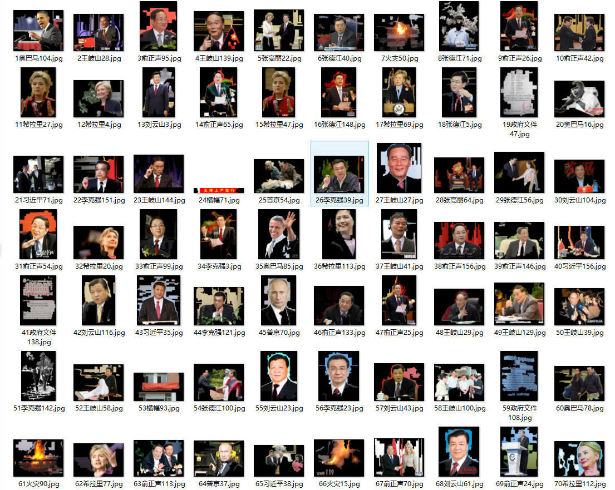

Gabor：

'2/10

'4/20

'4/30

'5/40

'5/50

'6/60

'6/70

'7/80

'8/90

'8/100



JCD：

'2/10

'2/20

'2/30

'3/40

'4/50

'5/60

'6/70

'6/80

'6/90

'6/100



PHOG：

'2/10

'3/20

'3/30

'4/40

'4/50

'4/60

'4/70

'4/80

'4/90

'4/100



Tamura：

'2/10

'2/20

'2/30

'2/40

'2/50

'2/60

'3/70

'3/80

'4/90

'4/100



李克强：

CEDD：

'2/10

'2/20

'2/30

'5/40

'6/50

'6/60

'7/70

'8/80

'10/90

'11/100

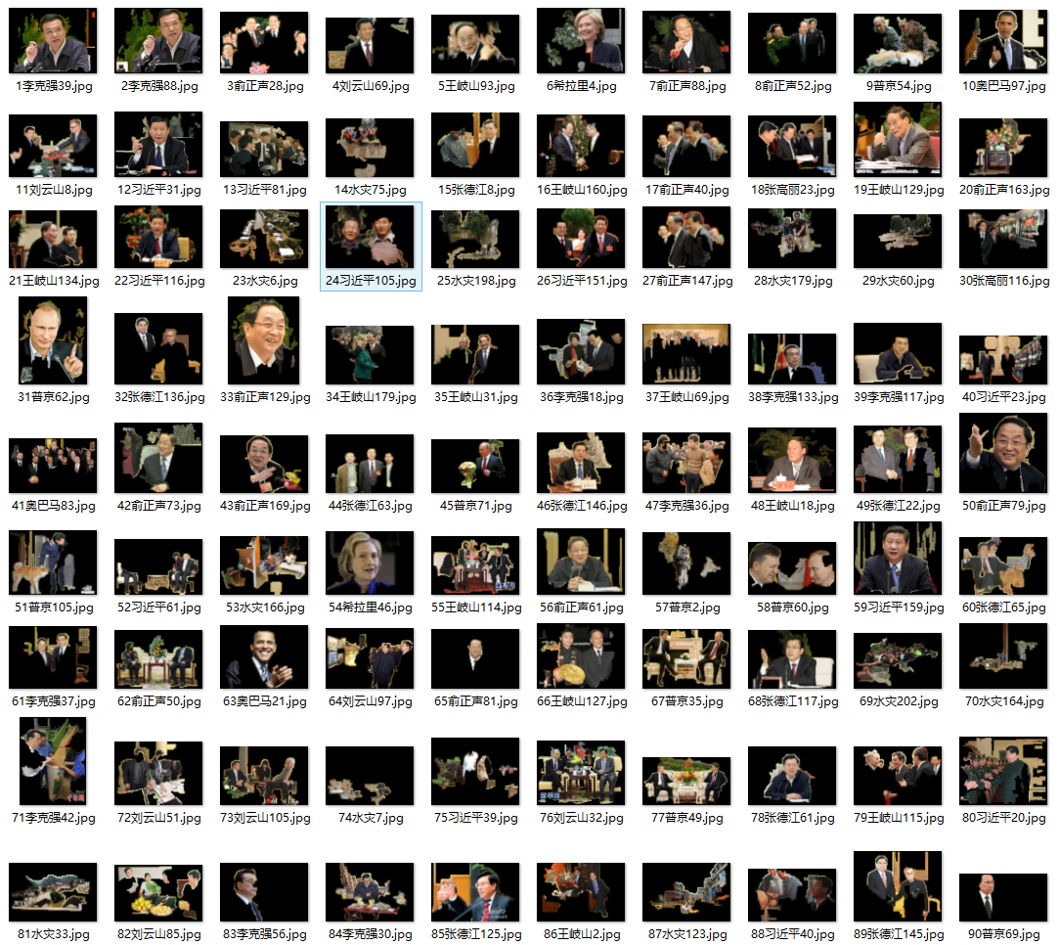

FCTH

'3/10

'4/20

'5/30

'6/40

'6/50

'8/60

'10/70

'10/80

'10/90

'11/100



EdgeHistogram

'2/10

'2/20

'2/30

'3/40

'4/50

'5/60

'5/70

'7/80

'7/90

'8/100

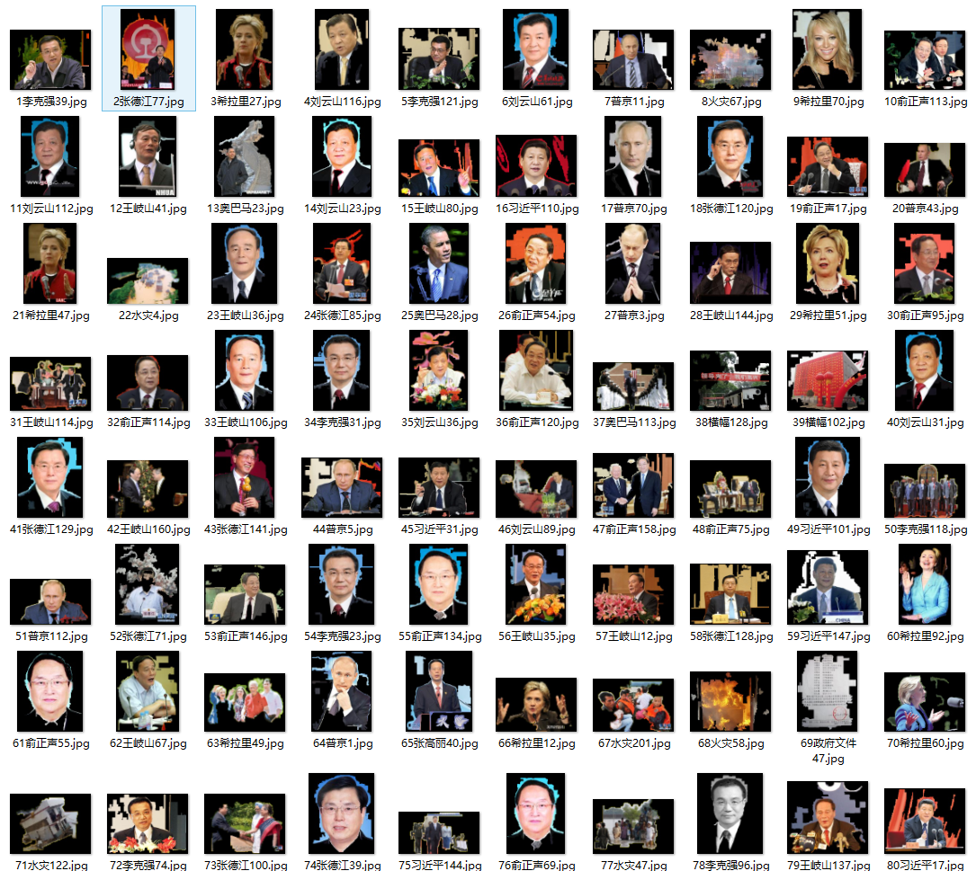

Gabor

'1/10

'1/20

'4/30

'7/40

'9/50

'11/60

'13/70

'13/80

'16/90

'17/100



JCD：

'2/10

'3/20

'3/30

'5/40

'6/50

'7/60

'8/70

'10/80

'10/90

'11/100

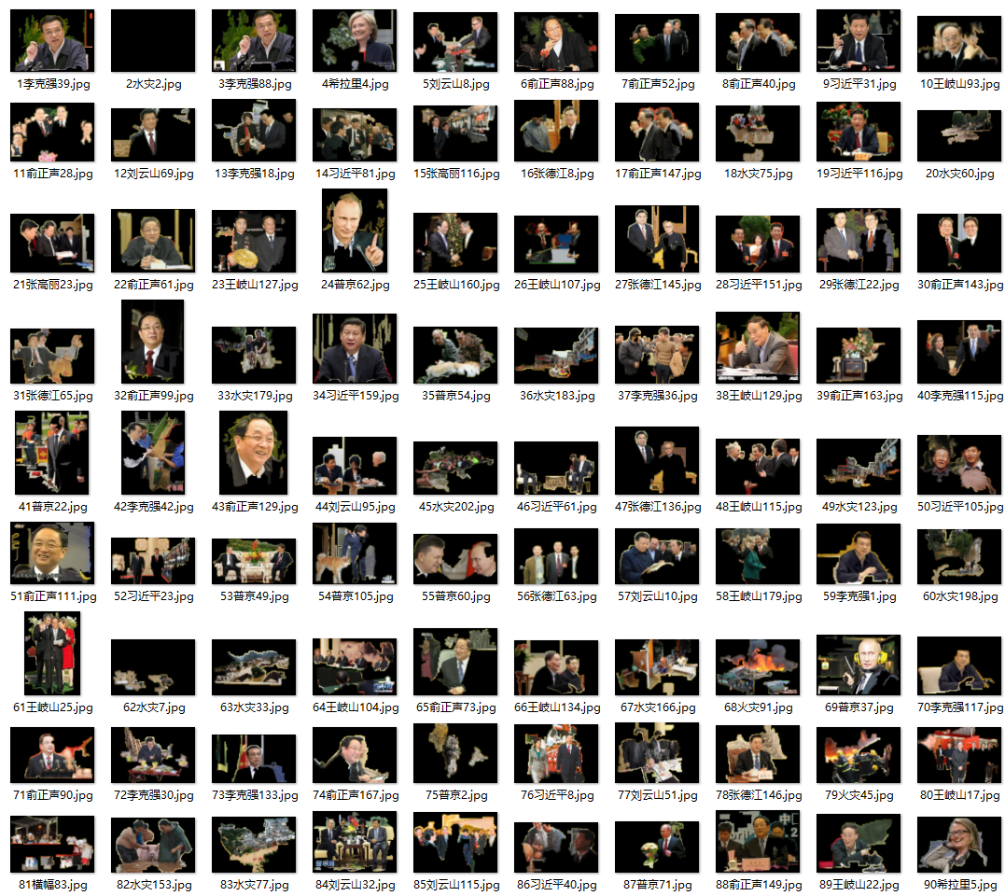

PHOG：

'2/10

'2/20

'3/30

'4/40

'5/50

'7/60

'10/70

'12/80

'12/90

'14/100



Tamura

'2/10

'2/20

'4/30

'5/40

'6/50

'7/60

'8/70

'9/80

'11/90

'14/100



刘云山：

CEDD：

'2/10

'3/20

'4/30

'5/40

'5/50

'5/60

'7/70

'7/80

'8/90

'8/100



FCTH

'2/10

'2/20

'2/30

'2/40

'2/50

'3/60

'4/70

'4/80

'4/90

'5/100



EdgeHistogram：

'2/10

'2/20

'2/30

'2/40

'2/50

'2/60

'2/70

'5/80

'5/90

'5/100



Gabor

'1/10

'1/20

'3/30

'3/40

'4/50

'6/60

'6/70

'8/80

'8/90

'8/100



JCD：

'2/10

'2/20

'3/30

'4/40

'6/50

'7/60

'8/70

'8/80

'9/90

'9/100



PHOG：

'1/10

'3/20

'3/30

'4/40

'5/50

'6/60

'7/70

'7/80

'9/90

'9/100



Tamura：

'1/10

'2/20

'4/30

'5/40

'7/50

'8/60

'8/70

'8/80

'8/90

'8/100

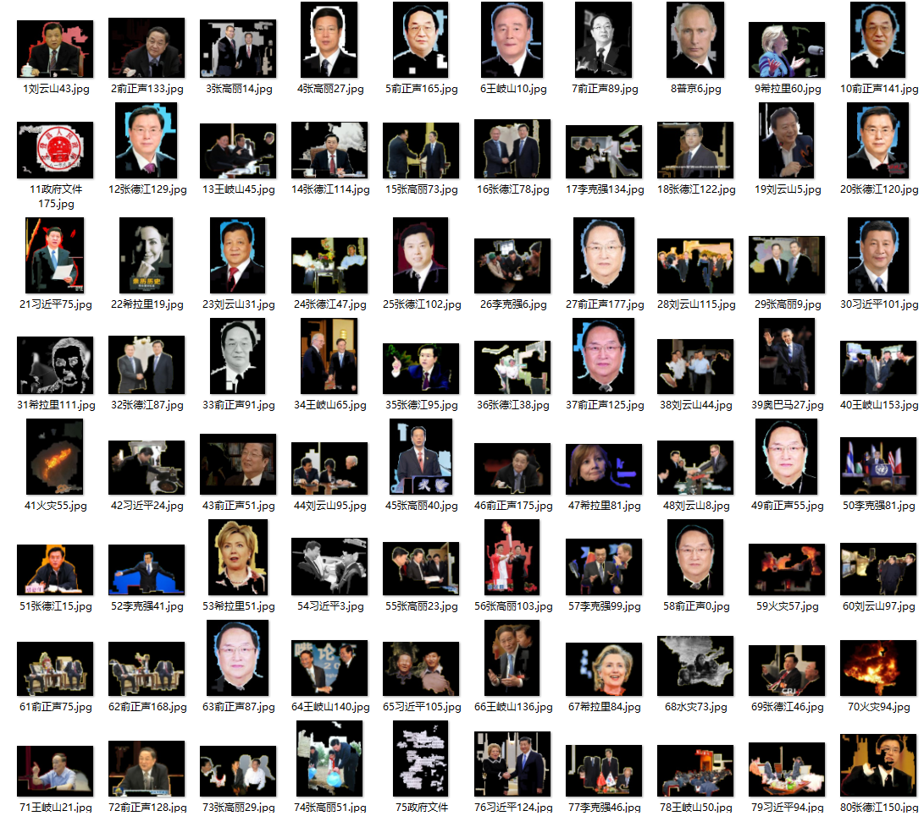

普京：

CEDD

'1/10

'2/20

'3/30

'3/40

'4/50

'5/60

'6/70

'7/80

'7/90

'7/100

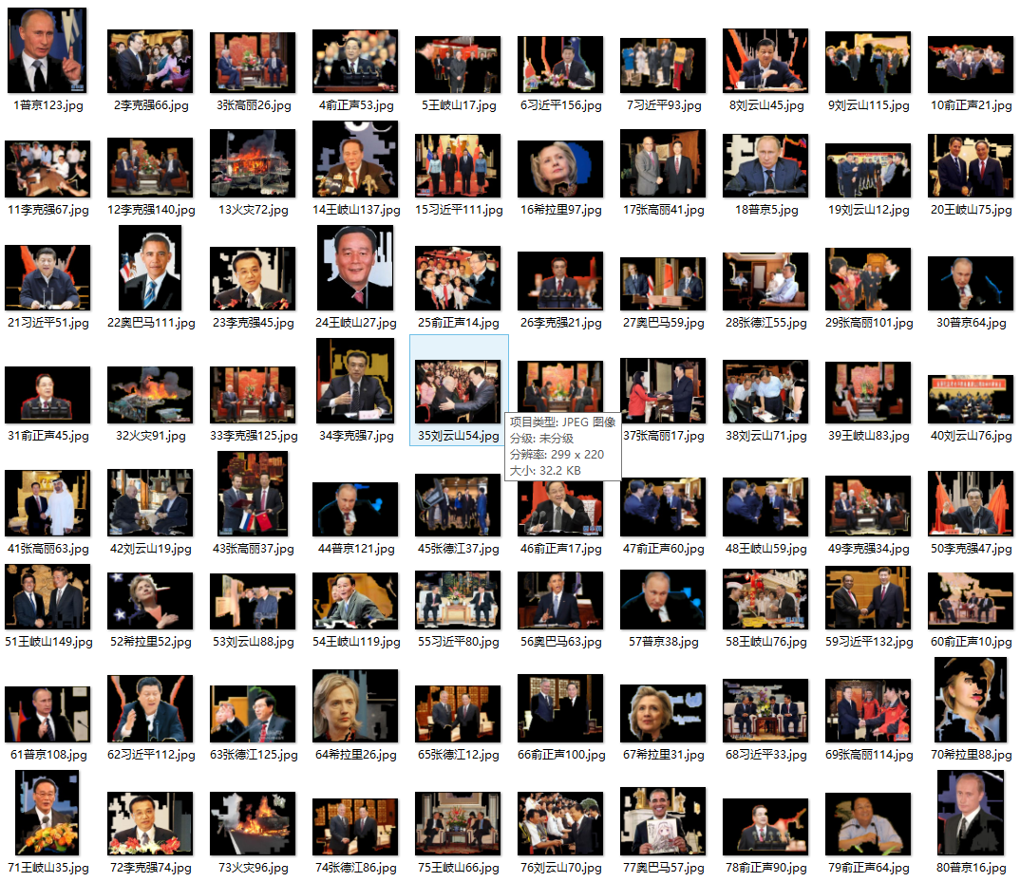

FCTH：

'2/10

'4/20

'6/30

'7/40

'7/50

'8/60

'11/70

'12/80

'13/90

'15/100



EdgeHistogram

'2/10

'2/20

'2/30

'3/40

'3/50

'3/60

'3/70

'5/80

'5/90

'5/100



Gabor：

'3/10

'4/20

'4/30

'4/40

'4/50

'5/60

'5/70

'7/80

'8/90

'9/100



JCD：

'2/10

'3/20

'4/30

'7/40

'7/50

'8/60

'9/70

'10/80

'11/90

'12/100

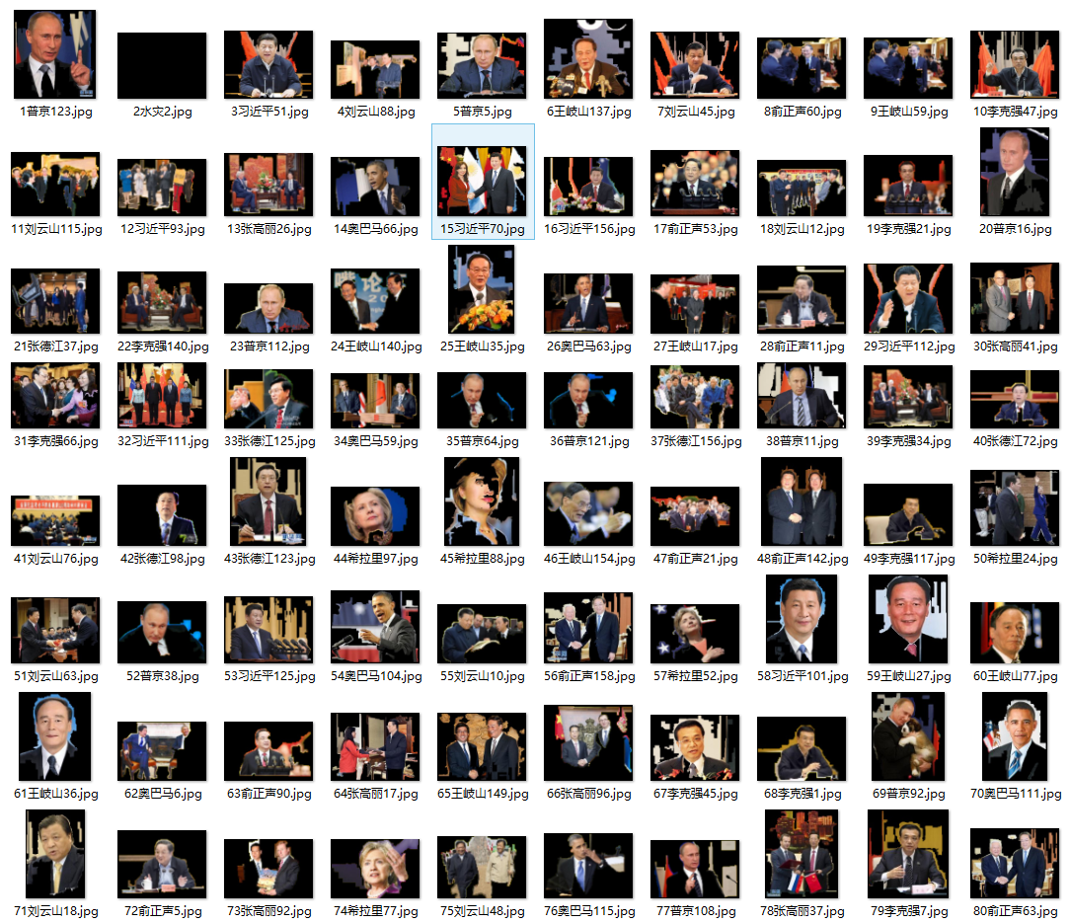

PHOG：

'2/10

'3/20

'5/30

'7/40

'7/50

'7/60

'7/70

'8/80

'8/90

'8/100



Tamura：

'1/10

'1/20

'2/30

'2/40

'4/50

'4/60

'5/70

'5/80

'7/90

'7/100

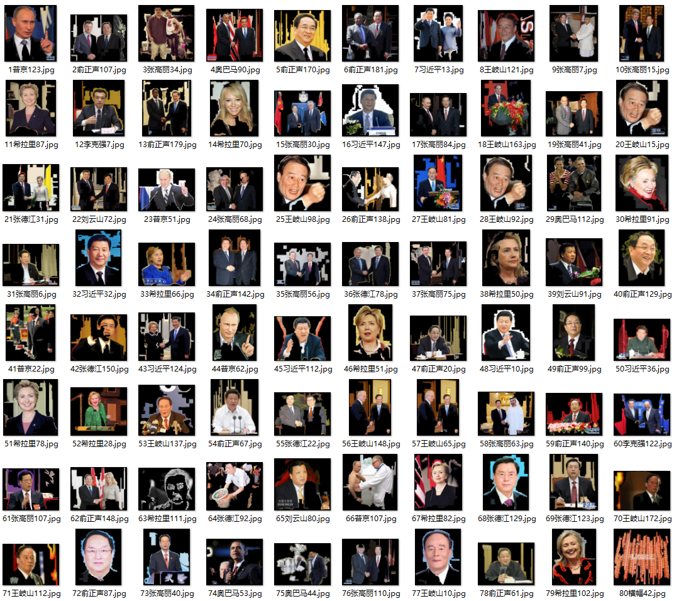

王岐山

CEDD：

'3/10

'4/20

'4/30

'5/40

'5/50

'9/60

'11/70

'12/80

'13/90

'13/100



FCTH：

'2/10

'4/20

'5/30

'9/40

'11/50

'14/60

'16/70

'16/80

'17/90

'19/100



EdgeHistogram：

'1/10

'2/20

'3/30

'5/40

'5/50

'6/60

'7/70

'8/80

'8/90

'9/100

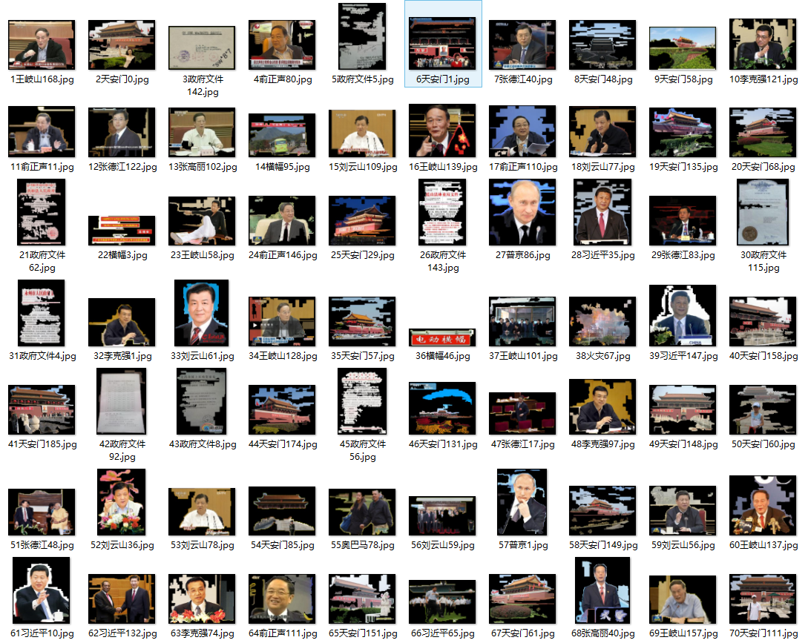

Gabor：

'4/10

'4/20

'5/30

'7/40

'9/50

'11/60

'11/70

'12/80

'14/90

'15/100



JCD：

'2/10

'4/20

'5/30

'8/40

'9/50

'9/60

'11/70

'13/80

'15/90

'15/100



PHOG

'1/10

'1/20

'1/30

'1/40

'1/50

'2/60

'2/70

'2/80

'4/90

'4/100

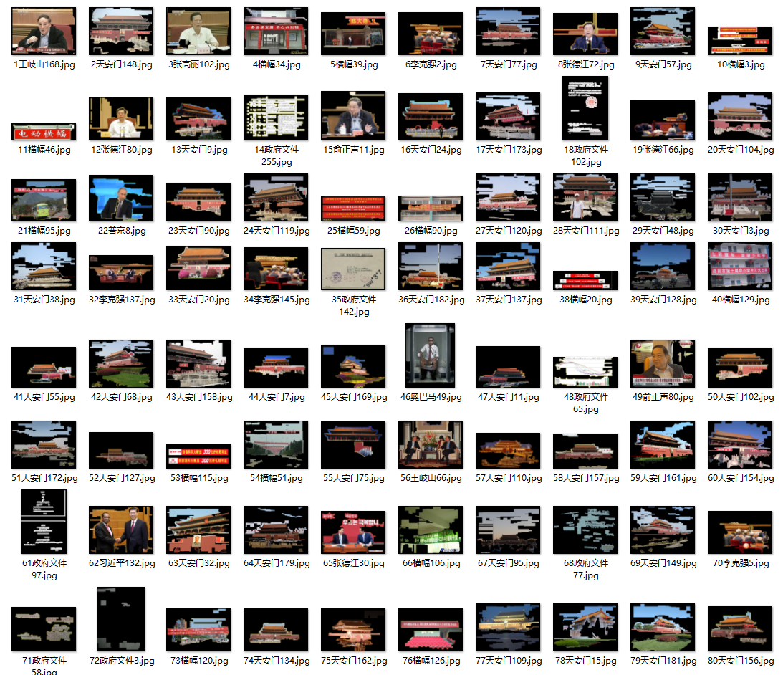

Tamura：

'1/10

'1/20

'1/30

'2/40

'3/50

'4/60

'4/70

'5/80

'6/90

'8/100

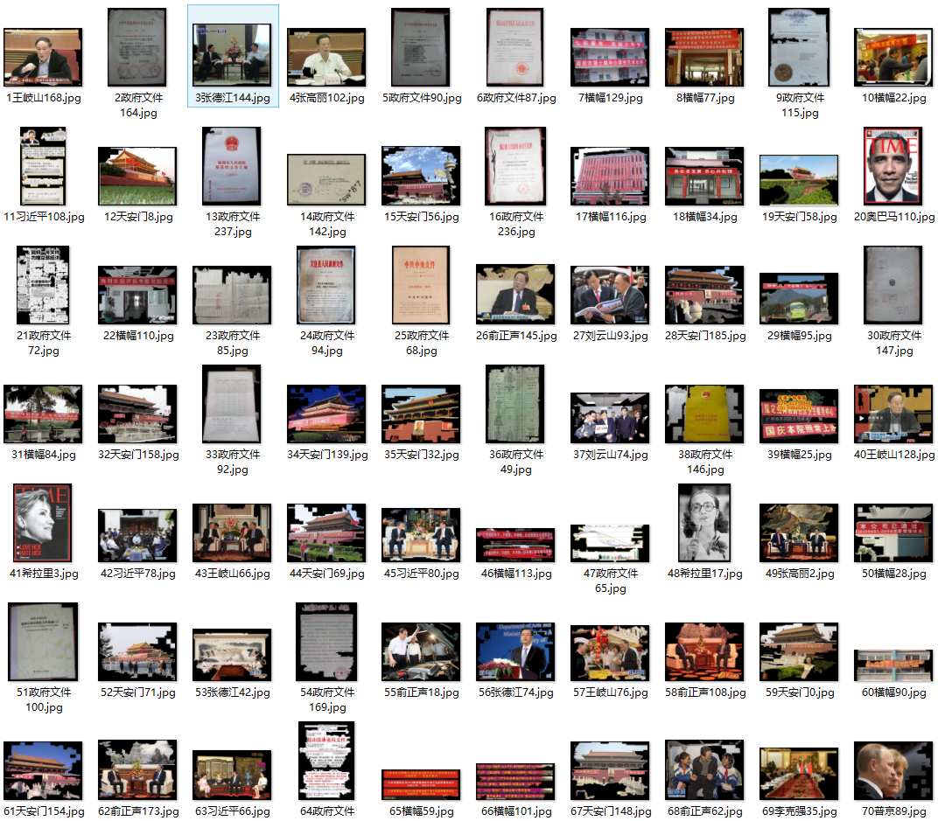

希拉里：

CEDD

'2/10

'3/20

'4/30

'4/40

'5/50

'6/60

'9/70

'9/80

'10/90

'12/100

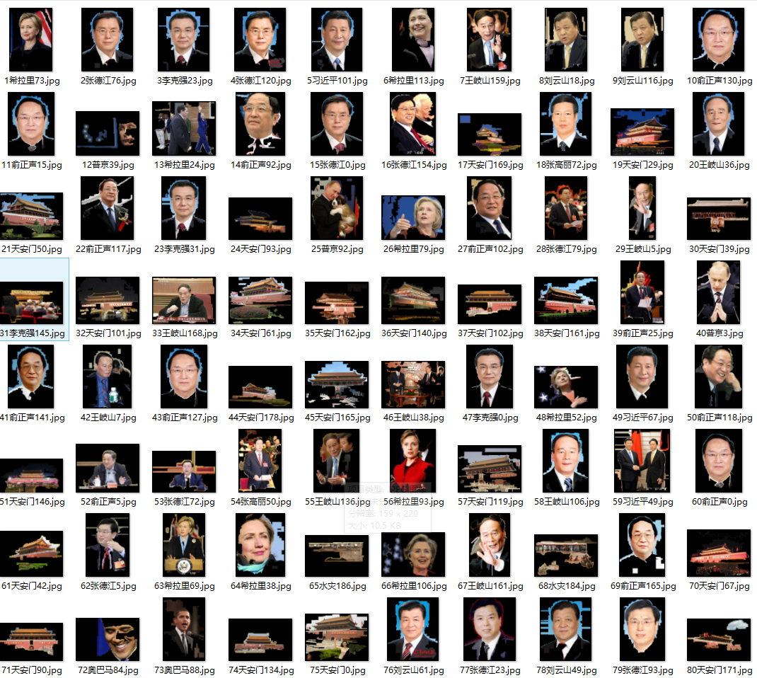

FCTH：

'3/10

'3/20

'4/30

'4/40

'5/50

'5/60

'5/70

'6/80

'7/90

'7/100



EdgeHistogram：

'3/10

'3/20

'3/30

'3/40

'4/50

'4/60

'6/70

'8/80

'9/90

'10/100

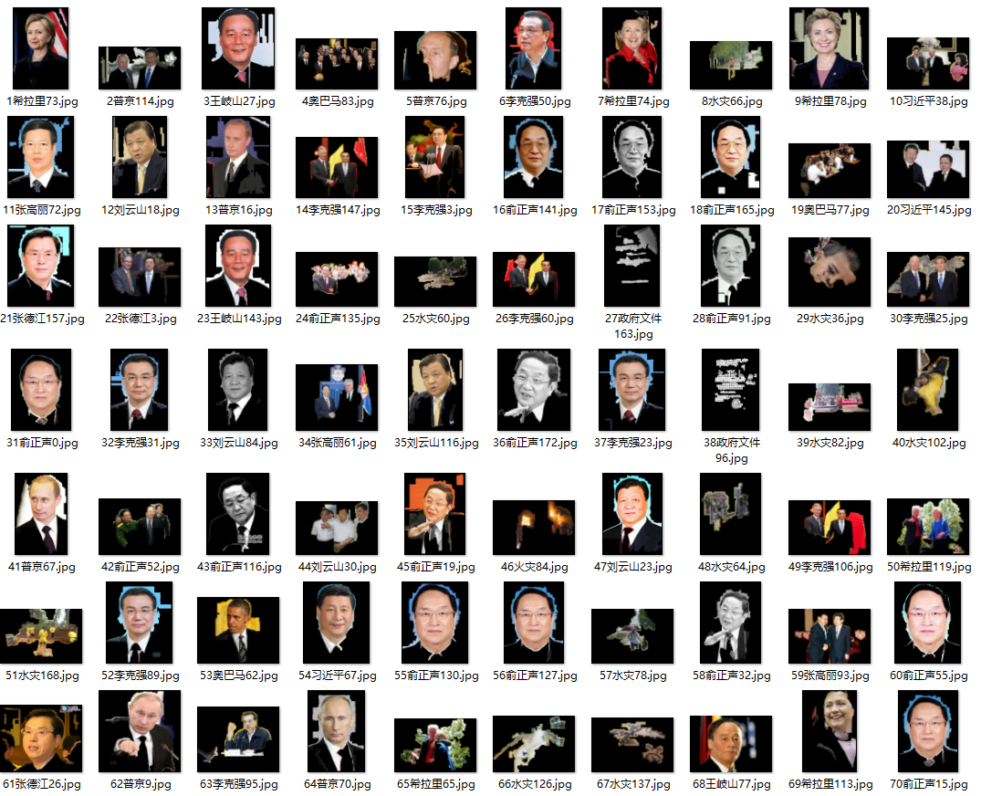

Gabor

'1/10

'1/20

'1/30

'1/40

'2/50

'2/60

'2/70

'3/80

'4/90

'6/100



JCD：

'2/10

'3/20

'3/30

'5/40

'5/50

'7/60

'8/70

'9/80

'11/90

'12/100

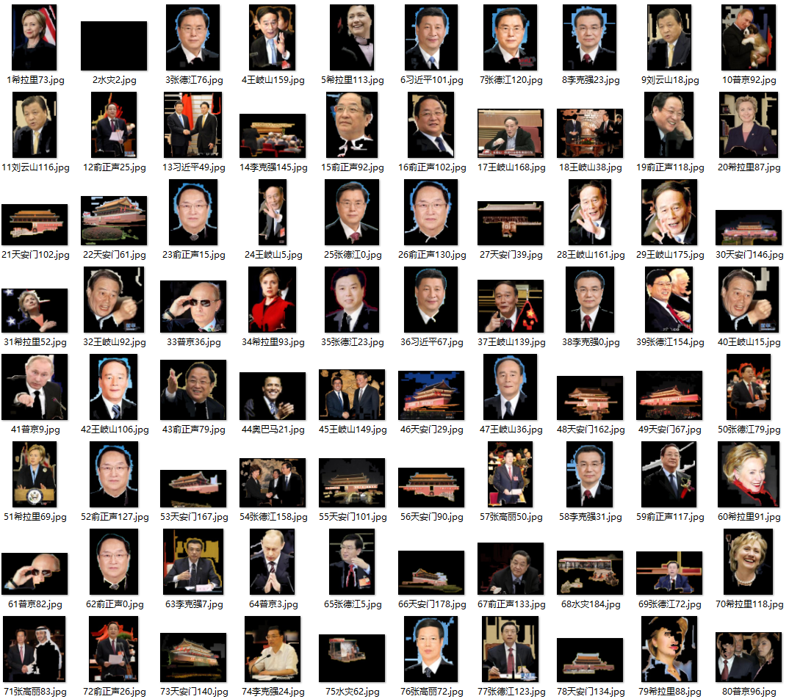

PHoG

'5/10

'6/20

'6/30

'6/40

'7/50

'7/60

'7/70

'7/80

'8/90

'10/100

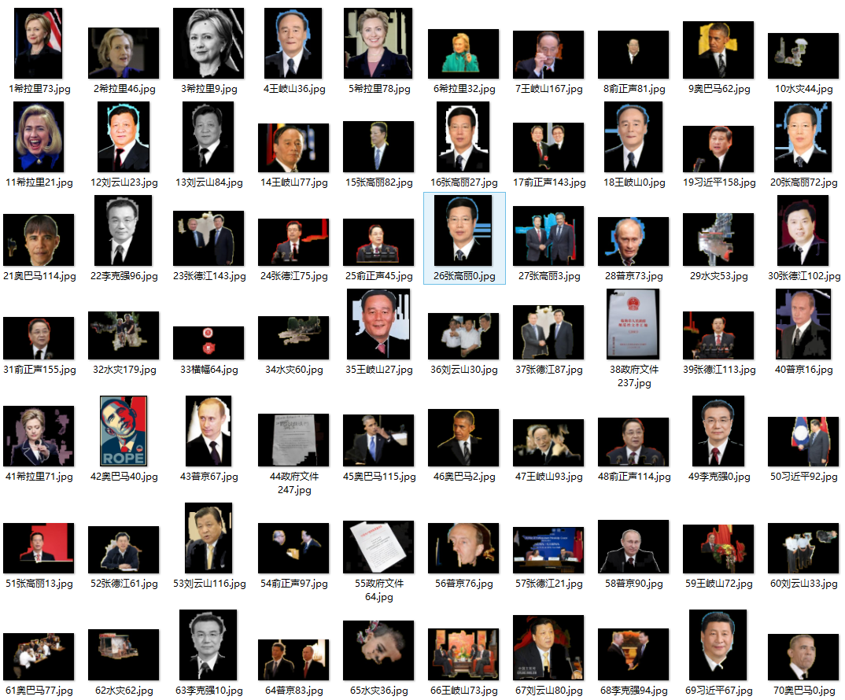

Tamura

'2/10

'4/20

'4/30

'6/40

'8/50

'9/60

'10/70

'10/80

'11/90

'11/100



习近平：

CEDD

'4/10

'4/20

'4/30

'6/40

'7/50

'9/60

'9/70

'10/80

'11/90

'13/100



FCTH

'1/10

'3/20

'5/30

'7/40

'7/50

'9/60

'11/70

'12/80

'13/90

'15/100



EdgeHistogram

'1/10

'1/20

'4/30

'6/40

'6/50

'6/60

'7/70

'7/80

'8/90

'8/100

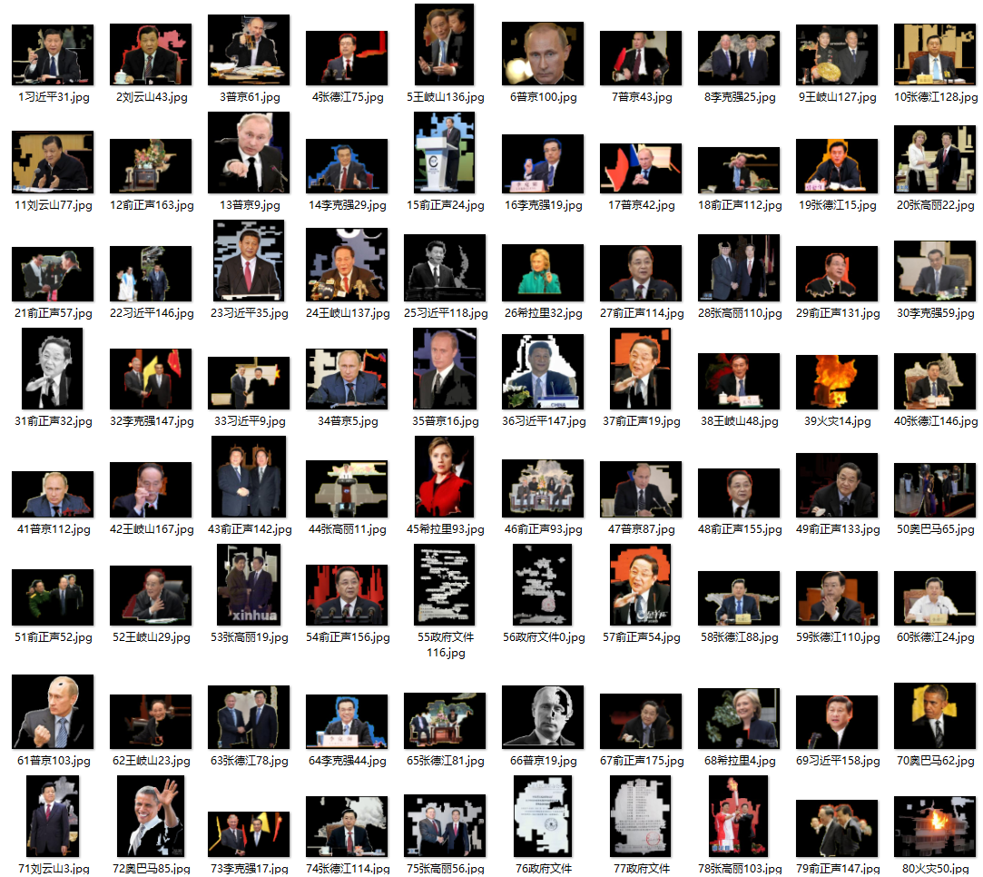

Gabor

'1/10

'3/20

'3/30

'4/40

'4/50

'6/60

'6/70

'7/80

'7/90

'7/100



JCD

'4/10

'4/20

'5/30

'10/40

'11/50

'12/60

'12/70

'12/80

'13/90

'13/100



PHOG

'1/10

'1/20

'3/30

'5/40

'5/50

'6/60

'8/70

'10/80

'10/90

'10/100



Tamura

'2/10

'2/20

'4/30

'6/40

'7/50

'7/60

'10/70

'10/80

'11/90

'11/100



俞正声

CEDD

'2/10

'2/20

'3/30

'4/40

'4/50

'5/60

'7/70

'7/80

'7/90

'7/100



FCTH

'2/10

'2/20

'4/30

'8/40

'9/50

'10/60

'11/70

'11/80

'11/90

'12/100



EdgeHistogram：

'1/10

'4/20

'5/30

'7/40

'9/50

'13/60

'13/70

'14/80

'15/90

'16/100



Gabor

'2/10

'2/20

'3/30

'3/40

'3/50

'3/60

'3/70

'3/80

'3/90

'3/100



JCD

'1/10

'4/20

'5/30

'6/40

'7/50

'8/60

'9/70

'9/80

'10/90

'12/100



PHOG

'4/10

'5/20

'6/30

'6/40

'7/50

'8/60

'8/70

'9/80

'9/90

'10/100



Tamura

'2/10

'5/20

'6/30

'8/40

'8/50

'10/60

'11/70

'11/80

'12/90

'13/100

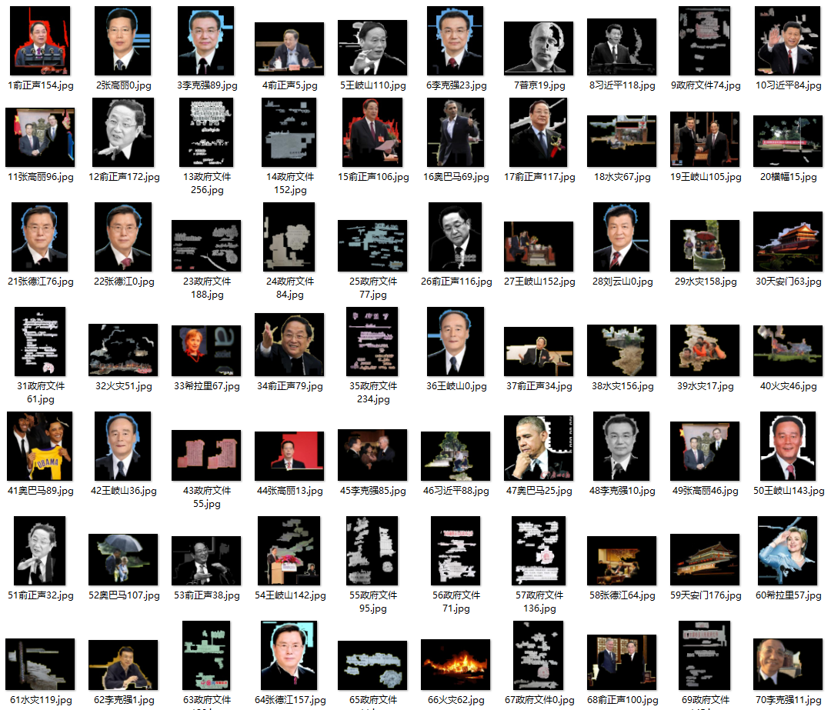

张德江

CEDD：

'2/10

'3/20

'4/30

'6/40

'7/50

'8/60

'10/70

'11/80

'11/90

'13/100



FCTH：

'2/10

'4/20

'5/30

'6/40

'7/50

'8/60

'8/70

'9/80

'13/90

'13/100



EdgeHistogram：

'2/10

'2/20

'2/30

'2/40

'3/50

'4/60

'6/70

'6/80

'8/90

'10/100



Gabor

'3/10

'3/20

'3/30

'4/40

'7/50

'9/60

'11/70

'12/80

'12/90

'13/100



JCD：

'2/10

'4/20

'5/30

'6/40

'6/50

'8/60

'9/70

'10/80

'13/90

'15/100



PHOG

'1/10

'3/20

'5/30

'6/40

'6/50

'9/60

'10/70

'10/80

'10/90

'10/100

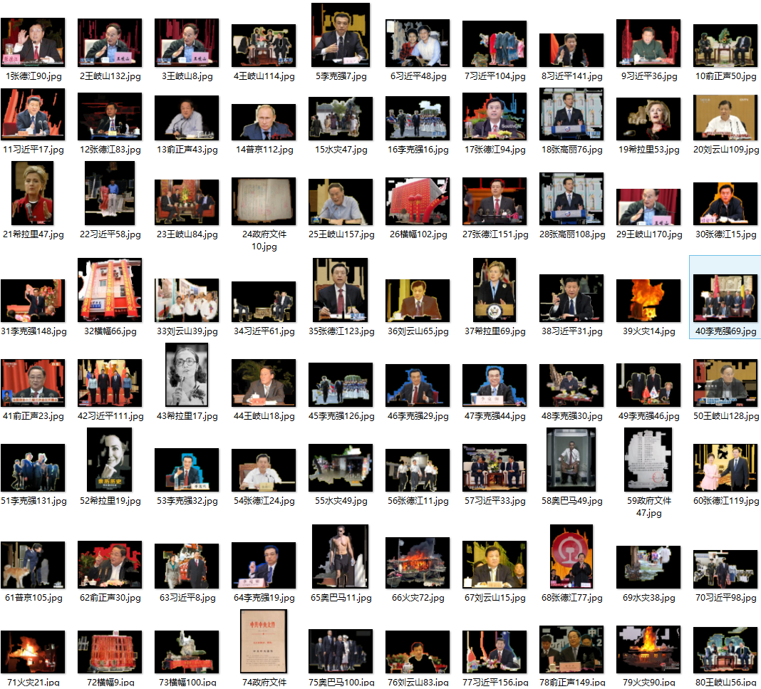

Tamura

'3/10

'4/20

'5/30

'6/40

'6/50

'6/60

'6/70

'7/80

'7/90

'8/100



张高丽

CEDD

'1/10

'1/20

'2/30

'2/40

'2/50

'2/60

'2/70

'3/80

'5/90

'6/100



FCTH

'1/10

'2/20

'5/30

'6/40

'7/50

'9/60

'9/70

'9/80

'9/90

'10/100



EdgeHistogram：

'1/10

'2/20

'2/30

'2/40

'2/50

'2/60

'2/70

'4/80

'5/90

'7/100

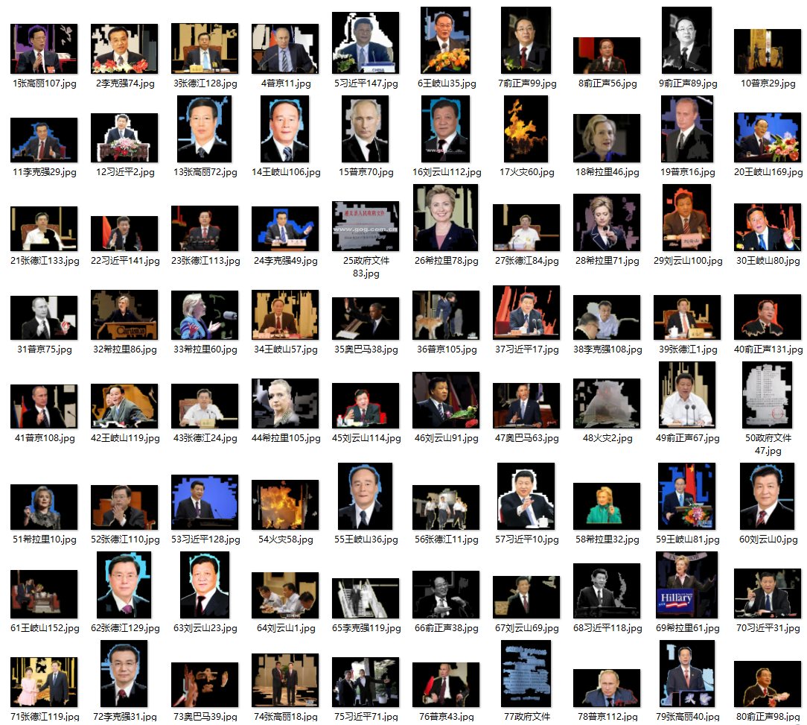

Gabor

'2/10

'2/20

'2/30

'2/40

'2/50

'2/60

'4/70

'5/80

'6/90

'7/100



JCD

'1/10

'1/20

'1/30

'2/40

'3/50

'3/60

'3/70

'4/80

'5/90

'7/100



PHOG

'2/10

'2/20

'2/30

'3/40

'5/50

'5/60

'5/70

'7/80

'7/90

'8/100



Tamura

'1/10

'3/20

'3/30

'3/40

'5/50

'5/60

'5/70

'6/80

'6/90

'7/100



## 距离测试

横幅：

Tanimoto：

'8/10

'13/20

'19/30

'24/40

'29/50

'32/60

'34/70

'39/80

'45/90

'48/100



余弦：

'7/10

'10/20

'14/30

'15/40

'16/50

'21/60

'23/70

'24/80

'24/90

'25/100



欧氏：

'3/10

'4/20

'5/30

'5/40

'6/50

'6/60

'6/70

'8/80

'10/90

'11/100

火灾：

欧氏：

'1/10

'2/20

'3/30

'5/40

'7/50

'7/60

'8/70

'8/80

'9/90

'10/100



余弦

'4/10

'6/20

'7/30

'9/40

'11/50

'15/60

'16/70

'16/80

'17/90

'20/100



Tanimoto：

'4/10

'5/20

'6/30

'6/40

'7/50

'7/60

'9/70

'9/80

'9/90

'10/100

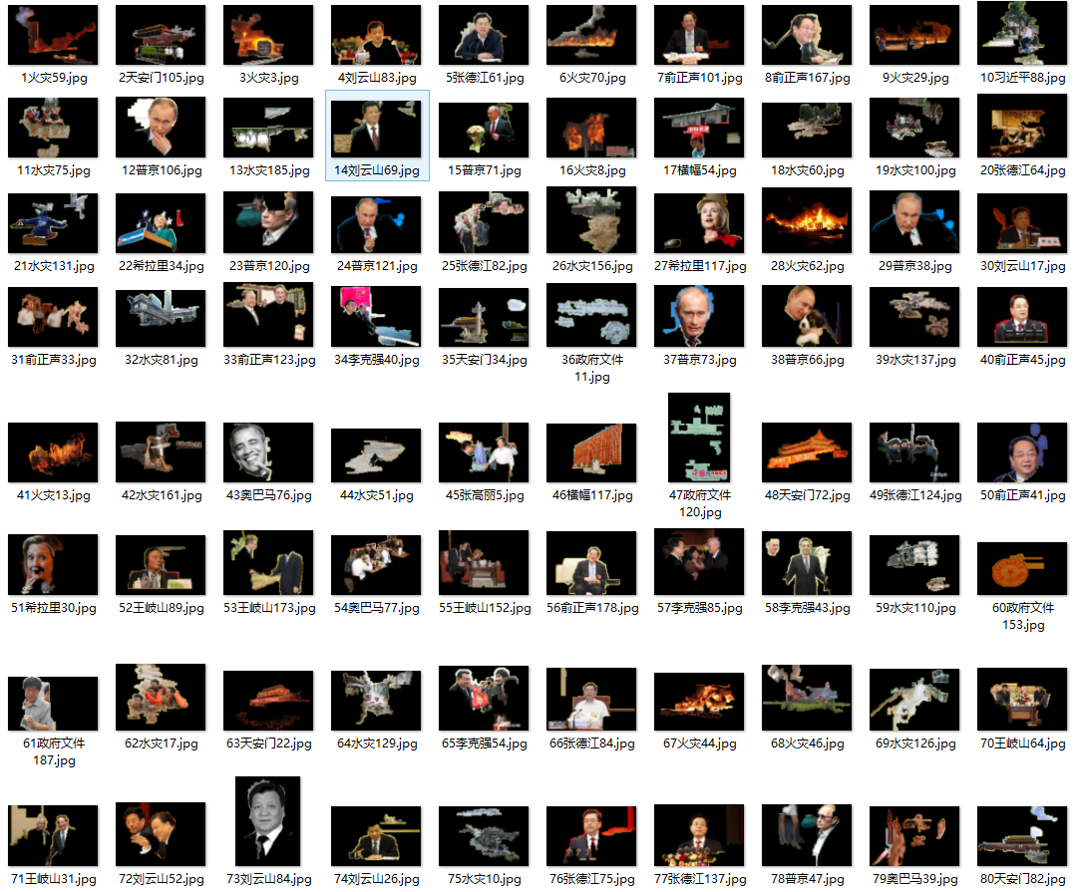

水灾：

欧氏：

'2/10

'5/20

'7/30

'11/40

'13/50

'17/60

'22/70

'25/80

'26/90

'29/100



余弦：

'3/10

'6/20

'10/30

'11/40

'12/50

'14/60

'15/70

'16/80

'17/90

'18/100



Tanimoto：

'4/10

'10/20

'11/30

'14/40

'18/50

'21/60

'21/70

'24/80

'25/90

'28/100

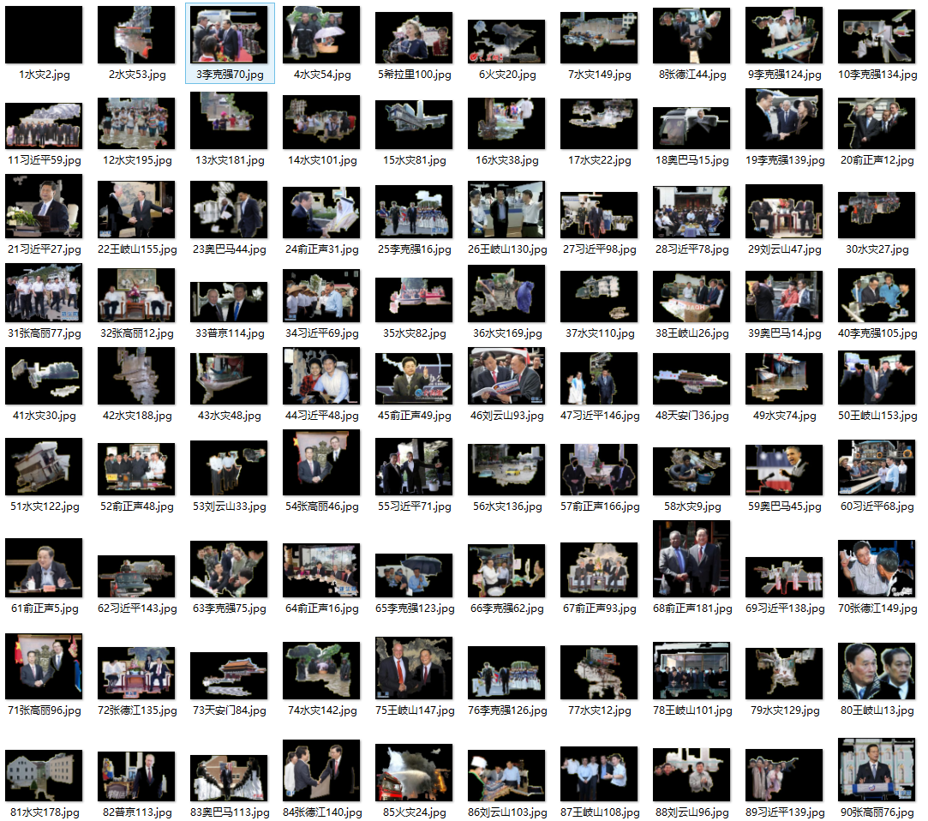

天安门：

欧式：

'6/10

'10/20

'11/30

'14/40

'18/50

'22/60

'24/70

'25/80

'30/90

'34/100



余弦：

'5/10

'10/20

'14/30

'16/40

'17/50

'20/60

'23/70

'27/80

'31/90

'35/100

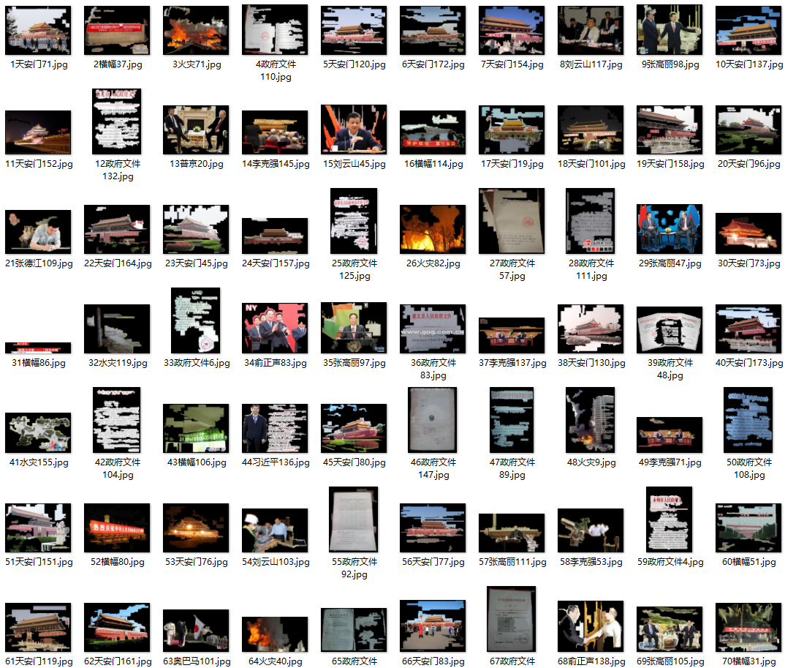

Tanimoto：

'7/10

'14/20

'21/30

'25/40

'28/50

'32/60

'34/70

'36/80

'40/90

'41/100

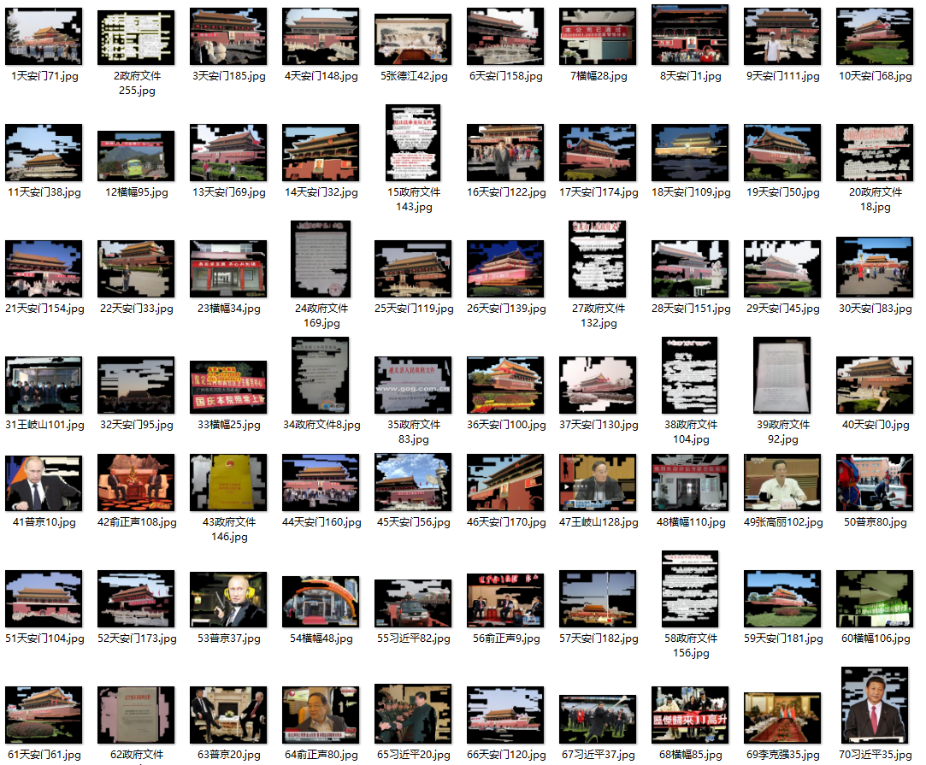

政府文件：

欧氏：

'5/10

'9/20

'14/30

'18/40

'24/50

'28/60

'32/70

'37/80

'42/90

'44/100

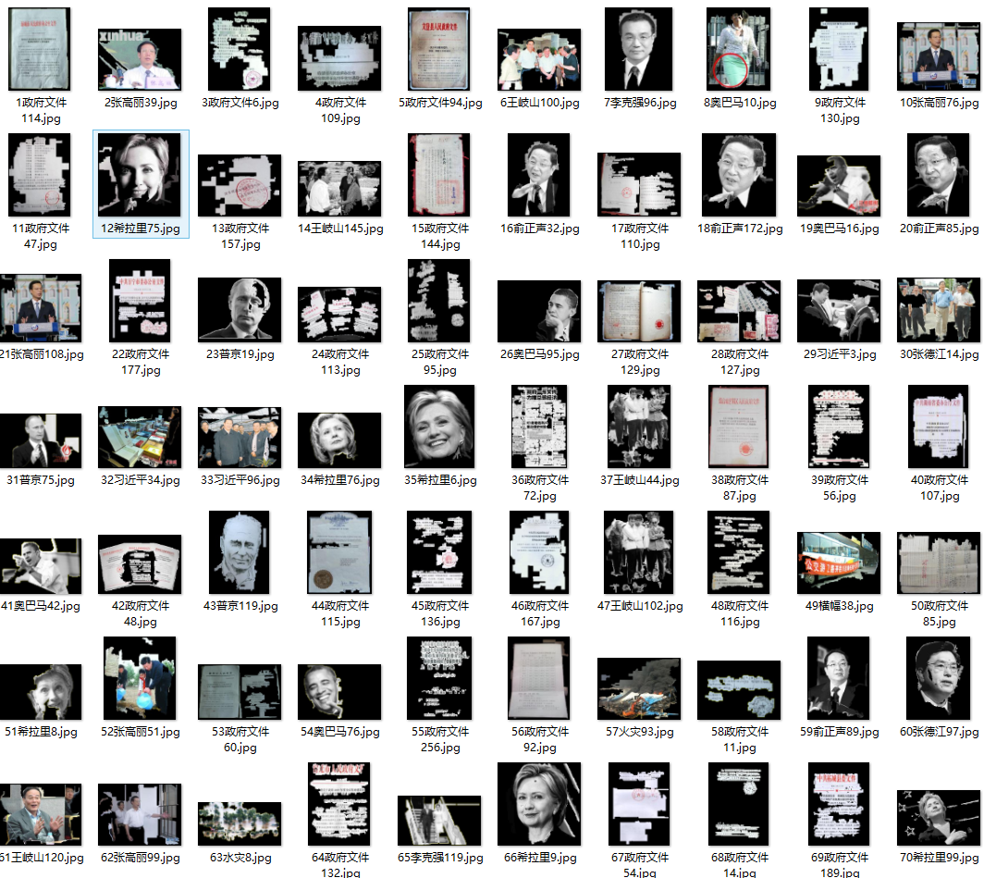

余弦：

'7/10

'11/20

'17/30

'21/40

'26/50

'32/60

'38/70

'42/80

'47/90

'52/100



Tanimoto：

'8/10

'11/20

'16/30

'21/40

'24/50

'30/60

'34/70

'36/80

'39/90

'43/100

